Omar Garcia

Advanced Computer Programming

Project 4

User’s Manual

Setup and Compilation

1. Download and unzip the submission from eLearning
2. The submission includes
   1. GUI.java
   2. Horse.java
   3. horseRace.java
   4. image folder
   5. StyleSheet.cs
3. Environment: This program has been tested using windows command line and a bat file
4. **Before you begin:** ensure you have Java JDK installed. For best results, make sure you have your java path configured in command Line
5. Compiling: Launch run.bat. This will automatically compile and launch the program.
6. User Input: User will have three options to choose from.
   1. Run: Race the horse. (only when a race is not in progress)
   2. Reset: Resets horse to starting line (Only after or before a race)
   3. Exit: closes the UI for the program

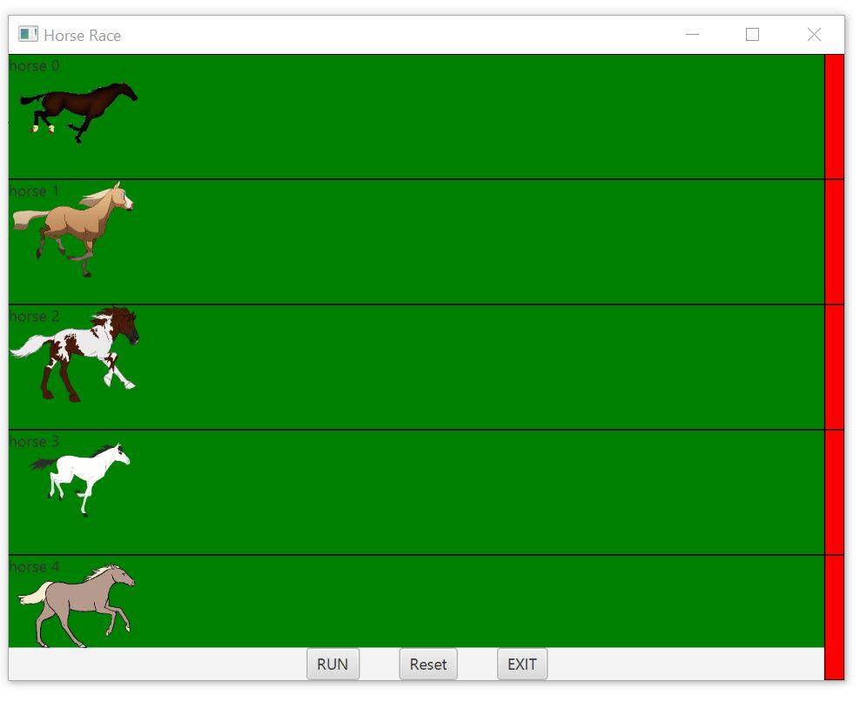

1. Output: The program will inform the user of a winner

